**Forecasting in Excel**

**3 Methods:**

1. Using Formula
2. Using Graph
3. Using Forecast Sheet

Training data in Excel file:

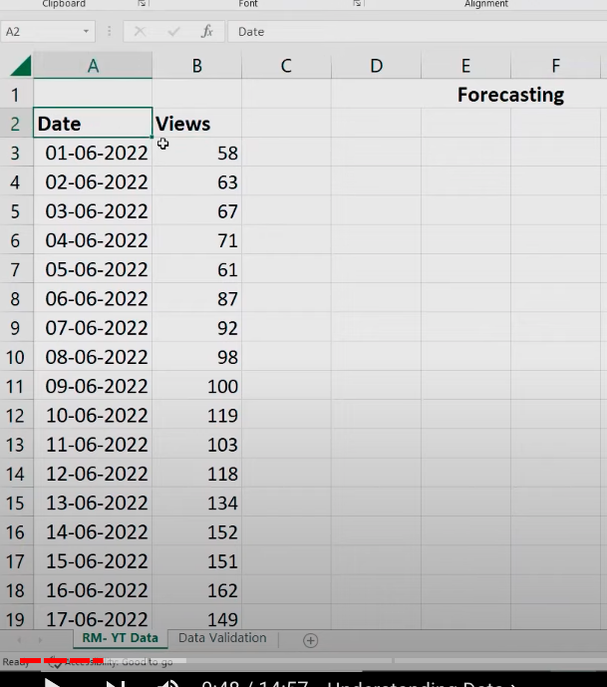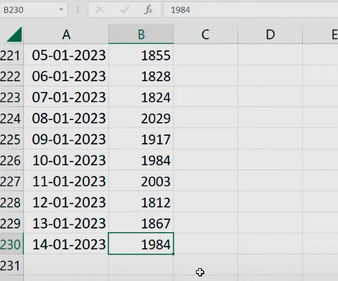

Testing data in Excel file:

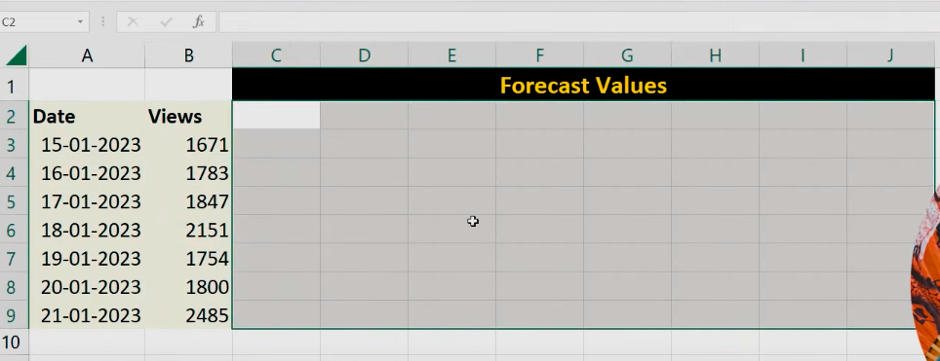



**DRAG** 14-01-2023 & get a new date(15-01-2023)

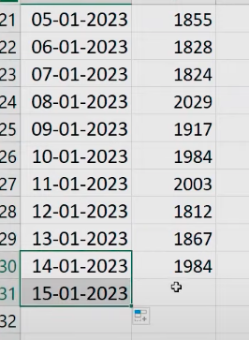

Checking the **FORECAST()**

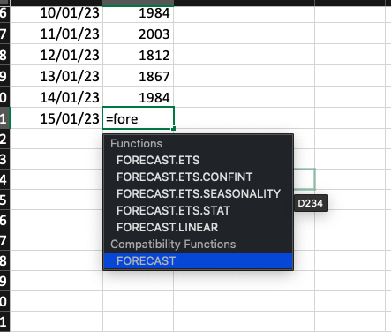

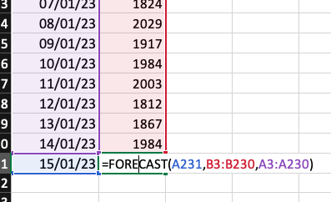

Remove, the decimal values

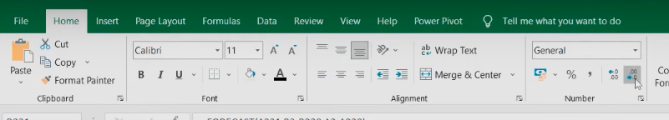

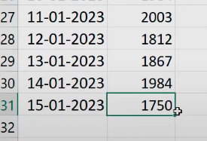

**DRAG** 15-01-2023 to 21-01-2023

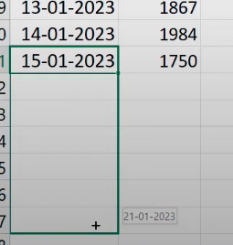

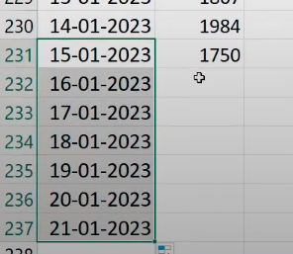

Now, copy all the predicted values into the Data Validation tab.

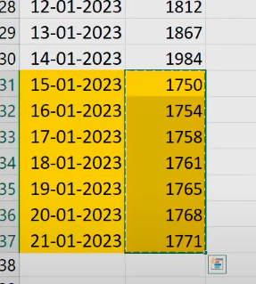

Copy the **predicted values** to the **Forecast values** section

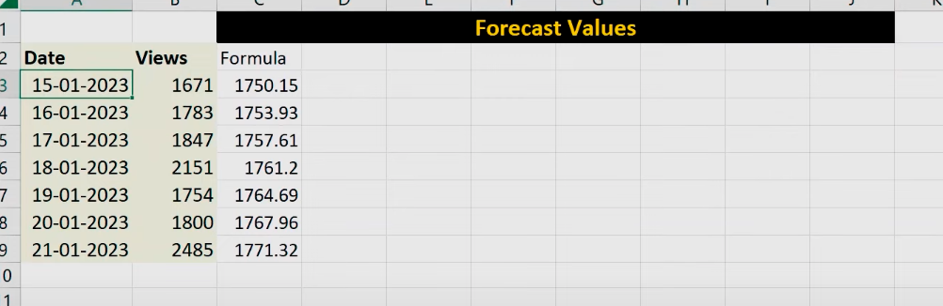

XXXXXXXXXXXXXXXX



Select both the columns data with [ctrl + shift + down arrow]

Then, go to **Insert** and select a **Line chart**

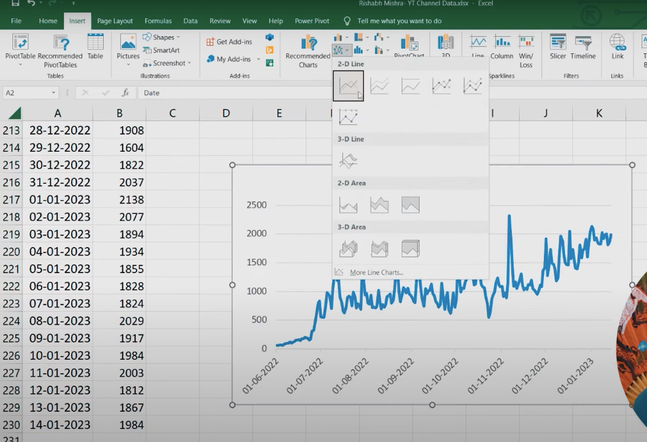

**Chart Elements** --> **Trendline**

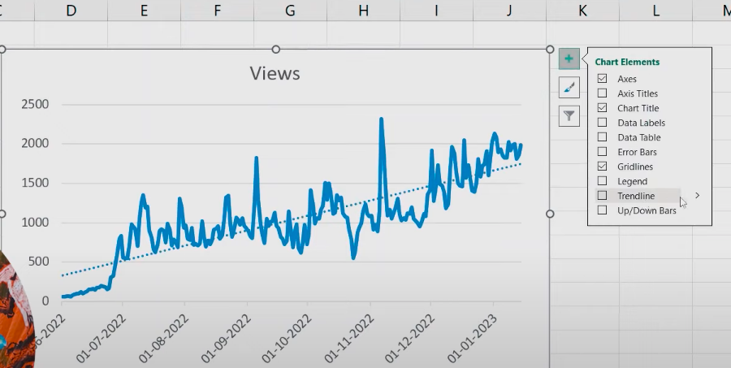

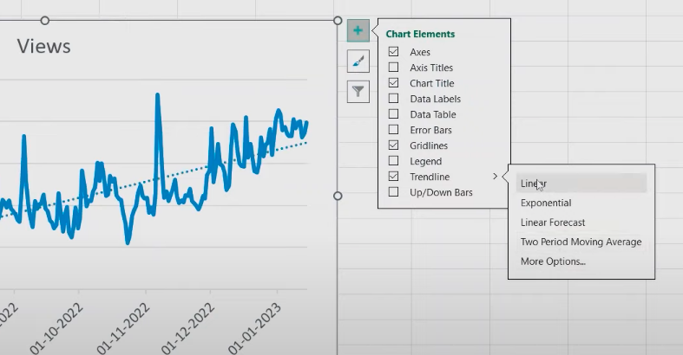

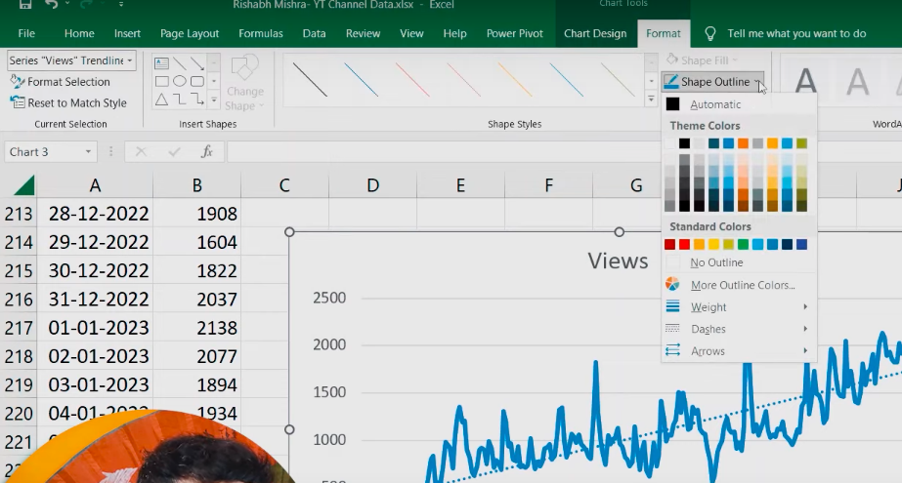

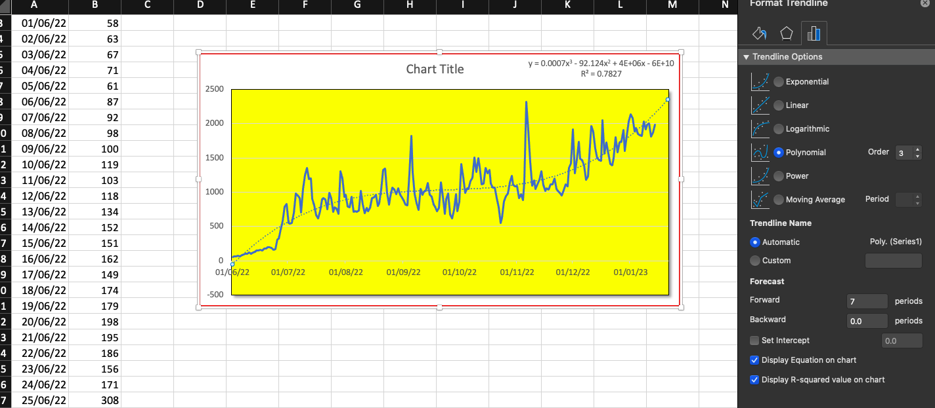

We selected a Polynomial cubic regression model for the forecasting.

Above, we can see, R2 value (error rate). R2 value is always between 0 and 1.

Higher the R2 value, higher the accuracy of predicted values.

XXXXXXXXXXXXXXXX



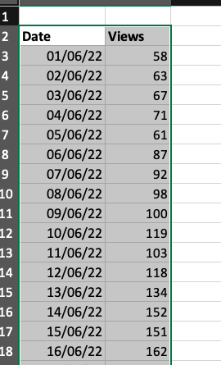

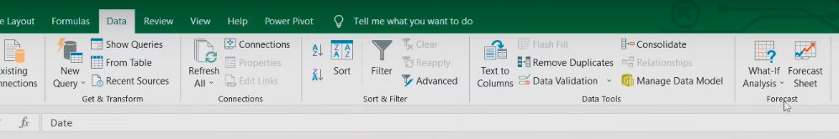

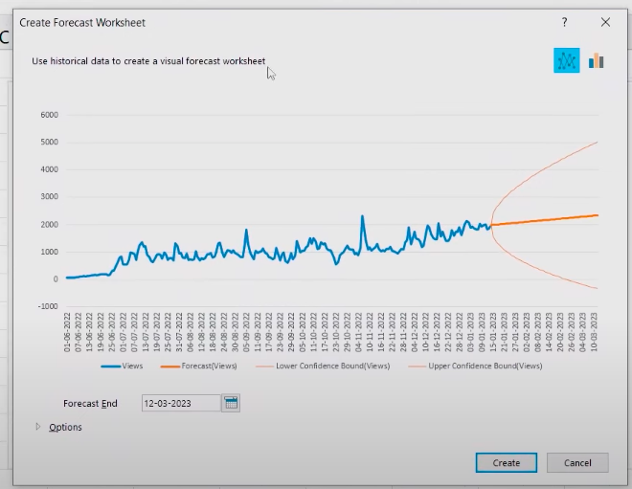

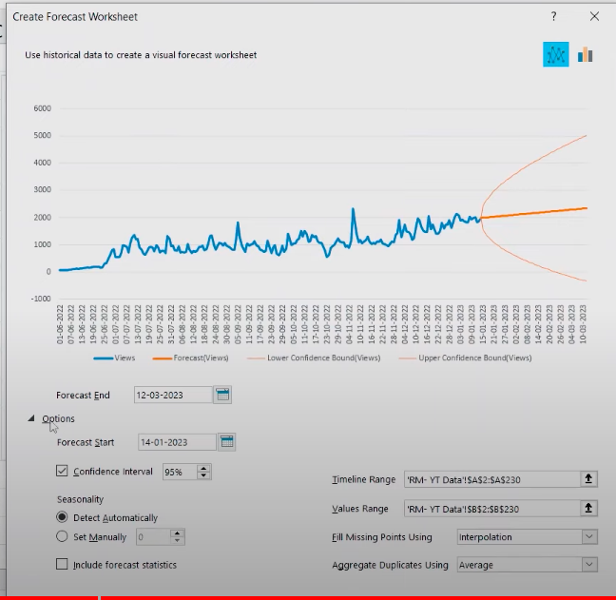

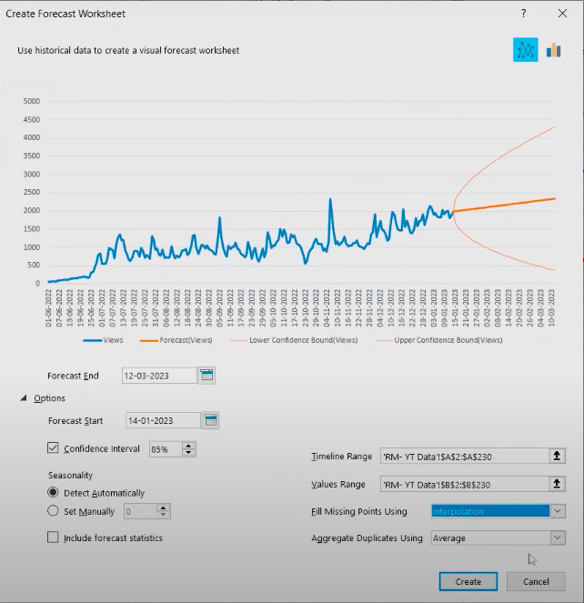

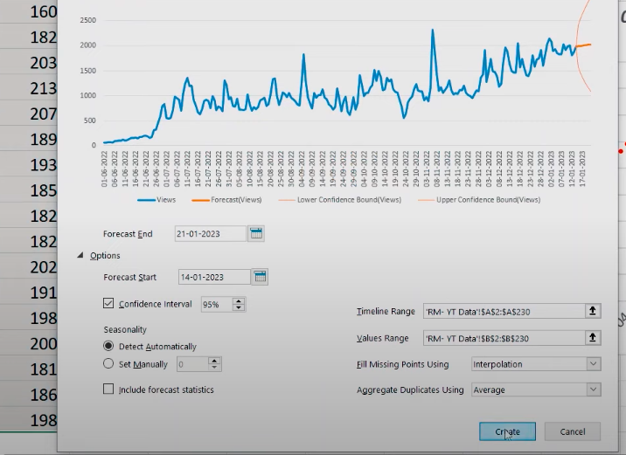

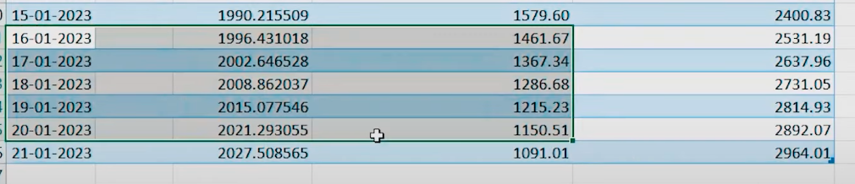

Finally, we got the Normal, Lower 85% and Upper 85% predicted values.